Experiment 3
Source code
Part 1
package experiment3t;
import java.util.*;
public class stack_extended extends stack{
stack_extended(){
super();
}
void push(int a){
this.a[this.top] = a;
this.top++;
this.display();
}
void pop(){
System.out.println("Message "+a[top-1]);
this.top--;
this.display();
}
void display(){
System.out.println("Current stack contains: ");
for(int j=0;j<top;j++){
System.out.println(a[j]+"\t");
}
}
}
package experiment3t;
import java.util.*;
public class stack {
protected int a[];
protected int top;
stack(){
a = new int[5];
top = 0;
}
}
package experiment3t;
import java.util.*;
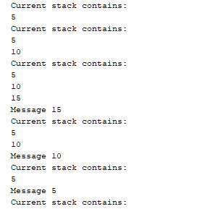
public class Experiment3t {
public static void main(String[] args) {
// TODO code application logic herE
stack_extended es = new stack_extended();
es.push(5);
es.push(10);
es.push(15);
es.pop();
es.pop();
es.pop();
}
}

Part 2
package experiment3_part2;
import java.util.*;
public class Experiment3_part2 {
public static void main(String[] args) {
Subdomain s=new Subdomain();
System.out.println("Single level");
s.pri();
Son s1=new Son();
System.out.println("multilevel");
s1.pr();
daughter1 s2=new daughter1();
System.out.println("heirarchical");
s2.d1();
daughter2 s3=new daughter2();
System.out.println("heirarchical");
s3.d2();
}
}

Single level
package experiment3_part2;
public class Domain {
void op(){
System.out.println("This is Domain");
}
}

package experiment3_part2;
public class Subdomain extends Domain {
void pri(){
super.op();
System.out.println("This is subdomain");
}
}

Multilevel
package experiment3_part2;
public class Grand {
void m1(){
System.out.println("This is Grand Father");
}
}

package experiment3_part2;
public class Father extends Grand {
void m2(){
super.m1();
System.out.println("This is Father");
}
}

package experiment3_part2;
public class Son extends Father {
void pr(){
super.m2();
System.out.println("This is son");
}
}

Hierarchical
package experiment3_part2;
public class amoeba {
void am(){
System.out.println("This is mother amoeba");
}
}

package experiment3_part2;
public class daughter1 extends amoeba {
void d1(){
super.am();
System.out.println("This is first daughter");
}
}

package experiment3_part2;
public class daughter2 extends amoeba {
void d2(){
super.am();
System.out.println("This is second daughter");
}
}
